Uncertainty-Aware Financial Forecasting:
Multivariate Time-Series with Planned Regime Detection
Interim Report — COM0415 Applied Deep Learning
Instructor: Doç. Dr. Fatma Patlar Akbulut
Lara Yıldırım • B. Derin Yüksel
2100003941@stu.iku.edu.tr • 2200001724@stu.iku.edu.tr

1. Introduction
Financial markets are inherently volatile and non-stationary, making reliable short-horizon forecasting a persistent challenge. Traditional point-estimate models offer no indication of when their predictions can be trusted, which is a critical limitation in risk-sensitive contexts. This project addresses this gap by developing an uncertainty-aware forecasting model for the Borsa Istanbul 100 Index (BIST 100), integrating Turkish equity data, global market signals, and US macroeconomic indicators.
In accordance with the project specification, the proposed system is designed to combine a transformer-based forecasting architecture, Bayesian dropout for epistemic uncertainty estimation, and a regime-detection mechanism that allows the model to adapt to changing market conditions. The present interim report documents progress on three of the four required deliverables — Related Work, Dataset Analysis, and Proposed Method — together with a baseline LSTM implementation that establishes a reference point for the subsequent Transformer and regime-aware components planned for the final report.

2. Related Work

2.1 Transformer Architectures for Financial Time-Series Forecasting
The application of deep learning to financial forecasting has evolved significantly from classical statistical methods toward attention-based architectures. Early approaches relied on autoregressive models such as ARIMA and ensemble methods like Random Forest, which remain competitive baselines due to their interpretability and robustness under strict leakage-controlled evaluation protocols [1]. However, these models struggle to capture nonlinear dependencies and structural breaks characteristic of financial markets. Recurrent architectures, particularly Long Short-Term Memory (LSTM) networks, addressed some of these limitations by modeling sequential dependencies through gated memory mechanisms, yet their performance remains asset-dependent and sensitive to evaluation design [1].
Motivated by the success of self-attention mechanisms in sequence modeling, recent work has explored encoder-only Transformer designs for one-step-ahead return forecasting using multivariate inputs that integrate lagged macroeconomic variables alongside technical indicators [1]. A key limitation of standard single-stream attention is its inability to distinguish between heterogeneous data types such as price signals and macroeconomic features. To address this, Hadizadeh et al. proposed a dual-stream attention architecture consisting of a Price Attention Network (PAN) and a Nonprice Attention Network (NAN), which maintain separate attention pathways for price-based and auxiliary financial inputs respectively [2]. The PAN processes historical price data through a Transformer encoder-decoder with Masked Multi-head Self-Attention, while the NAN handles macroeconomic and technical features via a ConvLSTM and BiGRU pipeline, with the two streams fused in a final prediction layer [2]. This design provides the structural blueprint for the multivariate integration strategy adopted in the present work, where Borsa Istanbul price data and FRED-MD macroeconomic indicators are treated as distinct input streams.

2.2 Uncertainty Quantification via Monte Carlo Dropout
Standard deep learning models for regression and classification do not inherently capture model uncertainty, often producing overconfident predictions even when the underlying data is ambiguous or sparse [3]. Gal and Ghahramani established the theoretical foundation for addressing this limitation by demonstrating that a neural network trained with dropout is mathematically equivalent to an approximation of a deep Gaussian process [3]. A practical consequence of this result is that epistemic uncertainty can be estimated without architectural modification: by performing multiple stochastic forward passes through the network with dropout active at inference time — known as Monte Carlo Dropout (MCD) — one obtains a distribution over predictions whose variance serves as a proxy for model uncertainty [3].
Despite its widespread adoption, conventional MCD has been criticised for producing poorly calibrated uncertainty estimates, largely because its quality is highly sensitive to the choice of dropout rate [4]. To address this, Asgharnezhad et al. proposed enhanced MCD frameworks that integrate an uncertainty-aware loss function with hyperparameter optimisation algorithms including Bayesian Optimisation, Grey Wolf Optimizer, and Particle Swarm Optimisation [4]. By incorporating predictive entropy directly into the training objective, these methods penalise incorrect predictions exhibiting low uncertainty, thereby improving the alignment between model confidence and prediction accuracy [4]. In the context of financial forecasting, well-calibrated uncertainty estimates are particularly valuable as they support risk-aware decision-making and the construction of reliable prediction intervals across varying market conditions. The project specification permits either attention-based entropy or Bayesian dropout mechanisms for uncertainty estimation; the present work adopts Monte Carlo Dropout due to its strong theoretical grounding and minimal architectural overhead.

2.3 Market Regime Detection via K-Means and Hidden Markov Models
Financial time series do not follow a single stationary process but instead alternate between distinct behavioural phases characterised by differing levels of volatility, return direction, and market sentiment [5]. Traditional econometric models such as ARIMA and GARCH are limited in their ability to capture these nonlinear regime-dependent dynamics, motivating the use of unsupervised and probabilistic approaches for structural market analysis [5].
K-Means clustering has been applied in this context to segment financial time series into homogeneous groups based on features such as logarithmic returns and rolling volatility, effectively distinguishing between bullish, bearish, and sideways market phases [5]. While clustering provides an efficient static segmentation of market states, it does not account for sequential dependencies or temporal transitions between states. The Hidden Markov Model (HMM) addresses this limitation by introducing a probabilistic framework that models the latent state sequence and estimates the transition probabilities between regimes over time [5]. A hybrid framework combining K-Means initialisation with HMM training has been shown to outperform standalone HMM models initialised with random parameters, producing more stable state estimates and improved log-likelihood scores [5]. The transition probability matrices derived from such models reveal that market regimes exhibit strong persistence, with self-transition probabilities exceeding 0.70 in both bullish and bearish states, confirming the presence of momentum effects in financial markets [5]. This hybrid K-Means and HMM framework constitutes the regime detection component planned for the final submission of this project, which will enable the forecasting model to dynamically condition its predictions on the prevailing market state.

3. Dataset Analysis

3.1 Data Sources and Collection
This study employs a multivariate dataset integrated from three primary financial and economic repositories. Daily equity price data for the Borsa Istanbul 100 Index (BIST 100, ticker: XU100.IS) and the S&P 500 Index (ticker: ^GSPC) were retrieved using the yfinance API, covering the period from January 2010 to April 2026. To incorporate macroeconomic context, we utilised the FRED-MD Monthly Database [6], a structured collection of 126 macroeconomic variables maintained by the Federal Reserve Bank of St. Louis.

3.2 Dataset Construction and Preprocessing
Constructing the unified dataset involved several preprocessing steps:
- Feature selection: From the 126 available FRED-MD indicators, three macroeconomic variables were selected based on their relevance to asset-pricing fundamentals and their distinct contributions to the macro state: the Consumer Price Index (CPIAUCSL, inflation), the Federal Funds Effective Rate (FEDFUNDS, monetary policy stance), and Industrial Production (INDPRO, real economic activity). A fourth candidate, the US Unemployment Rate (UNRATE), was examined during exploratory analysis but excluded from the final feature set; the justification for this decision is provided in Section 3.3.
- Resampling and alignment: Since the FRED-MD variables are reported at monthly frequency, they were resampled to daily frequency using a forward-fill strategy. Under this convention, each macroeconomic value is held constant across all trading days of the month until the next release. This preserves information-availability semantics (a given day uses only values that would have been published by that date) but also means that the effective resolution of the macro features remains monthly; their values are constant within each month, even though the data series itself is daily. BIST 100 and S&P 500 were aligned on the Turkish trading calendar, with forward-fill applied to handle non-overlapping holidays.
- Final shape: After alignment and dropping incomplete rows, the final integrated dataset comprises N = 4,223 daily observations with 5 features.
Table 1. Descriptive statistics of the final dataset (N = 4,223).
Feature | Mean | Std | Min | 25% / 75% | Max
BIST 100 Close (TRY) | 2,667.38 | 3,446.65 | 487.39 | 750 / 2,160 | 14,339.30
S&P 500 Close | 3,010.02 | 1,560.94 | 1,022.58 | 1,831 / 4,136 | 6,978.60
CPI (CPIAUCSL) | 259.53 | 32.98 | 217.20 | 234.7 / 287.7 | 326.59
Fed Funds Rate (%) | 1.45 | 1.82 | 0.05 | 0.10 / 2.39 | 5.33
Industrial Production | 99.34 | 3.36 | 84.56 | 98.35 / 101.37 | 104.10

3.3 Exploratory Data Analysis and Feature Selection
Figure 1 plots the BIST 100 closing price over the full sample period. The series exhibits a prolonged phase of relative stability from 2010 to late 2021, followed by an abrupt exponential acceleration driven in large part by high Turkish lira inflation. This non-stationary behaviour underscores two methodological consequences. First, modelling the raw price level would conflate genuine predictive signal with monetary debasement; the forecasting task is therefore formulated in terms of logarithmic returns, which are scale-invariant (Section 4.1). Second, the visible structural shift motivates the regime-detection component planned for the final report, which will allow the model to adapt its behaviour across qualitatively different market phases.
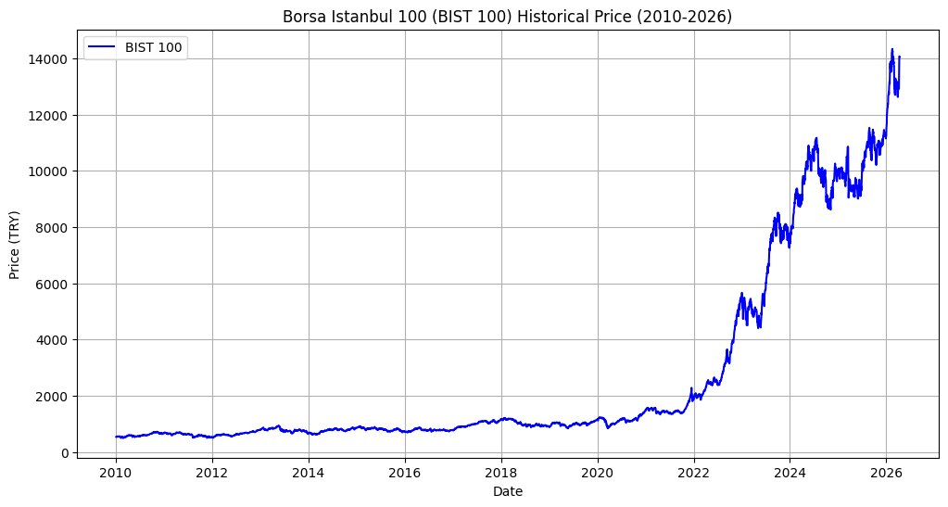
Figure 1. BIST 100 historical closing price, 2010–2026. Note the structural break in late 2021 corresponding to the onset of high Turkish lira inflation.
Figure 2 presents a Pearson correlation heatmap over the full feature universe initially considered, including the US Unemployment Rate (UNRATE) as a candidate macroeconomic variable. The heatmap reveals strong interdependencies between equity indices and macroeconomic factors — notably a high positive correlation between BIST 100 and CPI (r = 0.90) and between S&P 500 and CPI (r = 0.97), consistent with inflation's role as a dominant driver of nominal asset prices. Critically, the heatmap also reveals a very strong negative correlation between UNRATE and INDPRO (r = -0.85), reflecting the well-known Okun's Law relationship between labour-market slack and real economic activity. Because UNRATE shares approximately 72% of its variance with INDPRO, and because UNRATE itself exhibits only a weak direct correlation with BIST 100 (r = -0.41), we excluded UNRATE from the final feature set. The final five features (BIST 100, S&P 500, CPI, Federal Funds Rate, Industrial Production) therefore span approximately orthogonal dimensions of the market and macroeconomic environment — equity sentiment (domestic and global), inflation, monetary-policy stance, and real activity — without introducing the statistical redundancy that UNRATE would contribute.
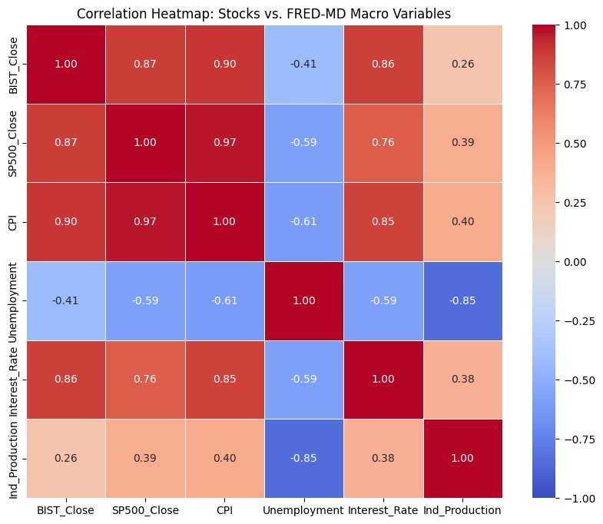
Figure 2. Pearson correlation heatmap over the full six-variable candidate set. The strong negative correlation between UNRATE and INDPRO (r = -0.85) motivates the exclusion of UNRATE from the final feature set to reduce redundancy.

4. Proposed Method

4.1 Task Formulation and Input Representation
The forecasting target is the one-day-ahead logarithmic return of the BIST 100 Index,

where P_t denotes the BIST 100 closing price on trading day t. Forecasting log returns rather than price levels is standard practice in the financial time-series literature [1] for three reasons: log returns are approximately stationary and scale-invariant, they are insensitive to the Turkish lira inflation that dominates the raw price series (Section 3.3), and they make it substantially harder for a model to achieve misleadingly low error by simply echoing the previous day's value. A predicted return can be converted back to a predicted price via P̂_{t+1} = P_t · exp(r̂_{t+1}) when a price forecast is required for downstream use.
The input to the model at each decision point is a multivariate tensor X ∈ ℝ^{T × D}, where T = 30 is the temporal lookback window (approximately six trading weeks) and D = 5 is the number of input features: (i) BIST 100 closing price, (ii) S&P 500 closing price, (iii) US Consumer Price Index, (iv) US Federal Funds Effective Rate, and (v) US Industrial Production Index. All features are standardised using z-score normalisation whose parameters are fit strictly on the training partition to prevent information leakage from the validation and test sets.

4.2 Transformer Architecture
The core predictive engine is an encoder-only Transformer. Since self-attention is inherently order-invariant, the 30 × 5 input tensor is first augmented with sinusoidal positional encodings to inject temporal information. The positionally encoded sequence is then processed by N stacked encoder blocks, each comprising a multi-head self-attention sublayer followed by a position-wise feed-forward network, with residual connections and layer normalisation applied after each sublayer. This architecture allows the model to dynamically weight the importance of specific historical days and cross-feature correlations, capturing dependencies between macroeconomic shifts and local price movements. Figure 3 presents the complete architectural overview.
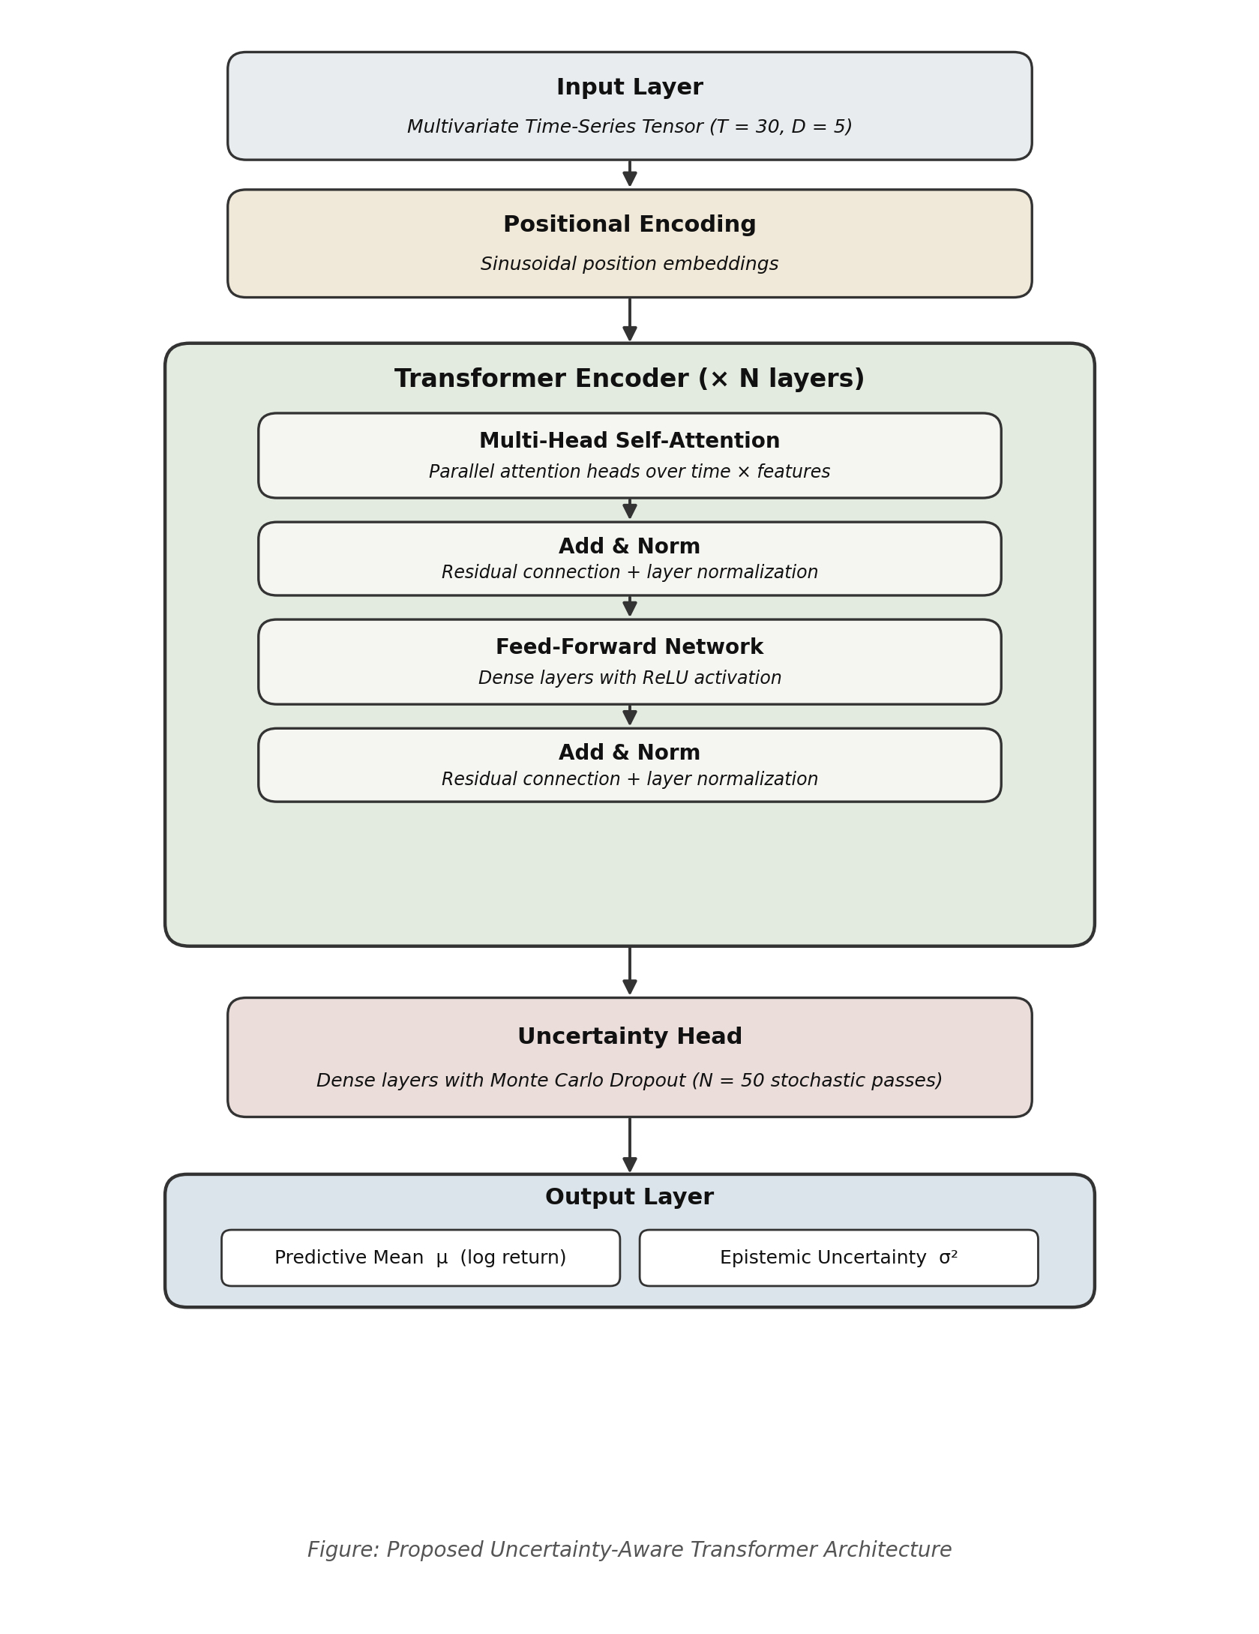
Figure 3. Proposed uncertainty-aware Transformer architecture. The model processes a 30 × 5 multivariate input tensor and uses Monte Carlo Dropout (N = 50) during inference to estimate the predictive mean μ (log return) and epistemic uncertainty σ².

4.3 Epistemic Uncertainty Estimation via Monte Carlo Dropout
A primary objective of the proposed architecture is to quantify the model's confidence in its predictions, particularly during volatile market regimes. To this end, Monte Carlo Dropout (MCD) is employed. Unlike standard dropout — which is active only during training — MCD keeps dropout layers stochastic at inference time, so that the network behaves as an approximate deep Gaussian process [3]. For a given 30-day input X, N = 50 independent stochastic forward passes are performed, producing a distribution of predictions {ŷ_1, ŷ_2, …, ŷ_N}.
The final forecasted log return is taken as the predictive mean μ of this distribution,

while the epistemic uncertainty — the model's own doubt about how well the input matches training-time regimes — is quantified by the predictive variance σ²,
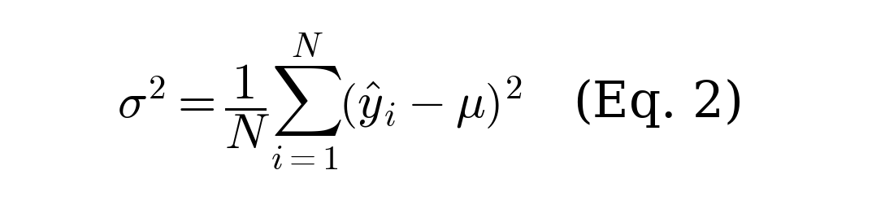
By monitoring σ², the system can flag predictions that occur during high-uncertainty market conditions, providing a risk-assessment signal alongside the point forecast. This capability is particularly valuable in the risk-aware forecasting strategies required by the project specification for the final report.

4.4 Planned Regime Detection Component
The Related Work (Section 2.3) and the project specification together motivate a regime-detection module that allows the forecasting model to dynamically adapt to changing market conditions. For the final submission we will implement a hybrid K-Means + Hidden Markov Model pipeline on the BIST 100 log-return and rolling-volatility series, following Haryani et al. [5]. The K-Means step will provide structural initialisation for a small number of discrete regimes (e.g., bullish, bearish, sideways), and the HMM will estimate the transition probabilities between these regimes. The inferred regime state at each day will then be provided to the Transformer either as an auxiliary input feature or through a gating mechanism on the prediction head, enabling regime-conditioned forecasts. The present interim report focuses on establishing the forecasting and uncertainty components; full integration of the regime module is scheduled for the final report.

5. Baseline Implementation

5.1 Baseline Model
As a reference point against which the proposed Transformer will be evaluated in the final report, we implemented a recurrent LSTM baseline in PyTorch. The choice of an LSTM is motivated by the financial forecasting literature [1], where recurrent networks are the dominant pre-Transformer deep-learning baseline for return prediction. The architecture consists of a two-layer LSTM with hidden dimension 64 and dropout 0.2 between layers, followed by a compact feed-forward head (64 → 32 → 1) that maps the representation of the final time step to a scalar predicted log return. The model has approximately 53,000 trainable parameters.

5.2 Training Setup
The following configuration is used consistently across all experiments:
- Chronological split (no shuffling): Train 2010-01-04 → 2022-12-31 (~3,270 days), Validation 2023-01-01 → 2023-12-31 (~252 days), Test 2024-01-01 → 2026-04-13 (~340 days).
- Feature scaling: StandardScaler fit only on the training partition; the same transformation is applied unchanged to the validation and test partitions to prevent leakage.
- Sliding windows: Each training example consists of 30 consecutive days of scaled features (30 × 5 tensor) and a scalar target equal to the next-day BIST 100 log return.
- Optimisation: Adam optimiser (learning rate 10⁻³), mean-squared-error loss, batch size 64, gradient clipping at max-norm 1.0, early stopping on validation loss with patience 7 and maximum 50 epochs.
- Reproducibility: Fixed random seed (42) across Python, NumPy, and PyTorch (including CUDA).

5.3 Evaluation Metrics
Three metrics are reported on the held-out test set. Mean Absolute Error (MAE) and Root Mean Squared Error (RMSE) are computed on the log-return scale and quantify average and squared-error magnitudes, respectively. Directional Accuracy reports the percentage of test days on which the sign of the predicted return matches the sign of the realised return, providing a measure of trading-relevant performance that is orthogonal to magnitude-based errors. To contextualise the results, we also report a naive baseline that predicts r̂ = 0 on every day (i.e., “tomorrow's price equals today's price”). This baseline is known to be difficult to beat on daily equity returns, and is a standard reference in the financial forecasting literature.

5.4 Results
Table 2. Baseline results on the held-out test set (2024-01 to 2026-04).
Model | MAE | RMSE | Dir. Acc. (%) | Params
Naive baseline (r̂ = 0) | 0.01080 | 0.01487 | — | 0
LSTM baseline | 0.01085 | 0.01493 | 48.63 | ~53k
Dir. Acc. is omitted for the naive baseline because the constant zero prediction has no defined sign.
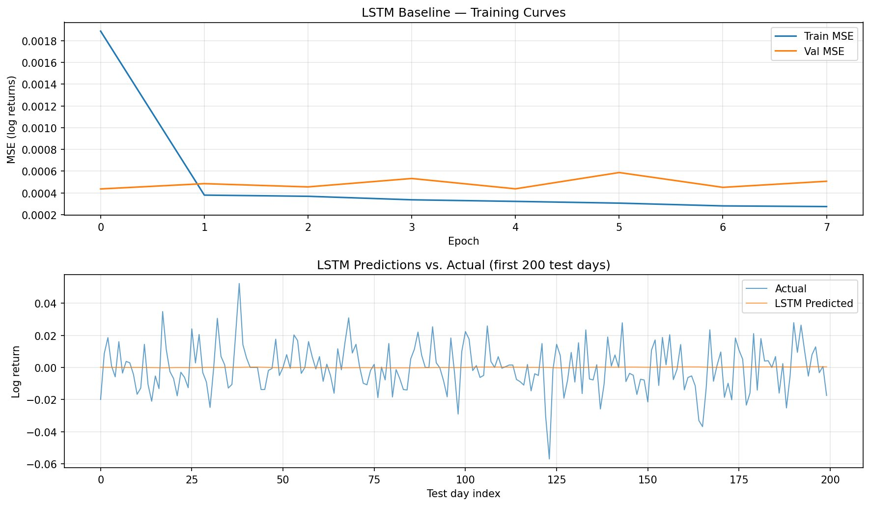
Figure 4. (Top) LSTM training and validation MSE over eight epochs, after which early stopping was triggered. (Bottom) LSTM predictions (orange) against actual next-day BIST 100 log returns (blue) over the first 200 days of the test set.

5.5 Interpretation
Three observations structure the interpretation of these results. First, the LSTM produces errors essentially indistinguishable from the naive baseline (MAE 0.01085 vs 0.01080, RMSE 0.01493 vs 0.01487), both differing by less than 1%, and achieves directional accuracy of 48.63% — slightly below chance. Second, the lower panel of Figure 4 reveals that the LSTM's output is in practice close to a constant near zero: the model has effectively learned to predict the mean of the training distribution rather than capturing any exploitable pattern. Third, the training curves show an immediate gap between training MSE (dropping from 0.0019 to 0.0003 within one epoch) and validation MSE (plateau near 0.00045), indicating that the model rapidly begins to fit training-set noise rather than signal.
This outcome is consistent with the well-documented difficulty of one-day-ahead equity return forecasting [1] and is informative rather than disappointing. It establishes a concrete performance floor for the project and identifies the specific failure modes — near-mean prediction and rapid overfitting — that the final Transformer-plus-uncertainty-plus-regime system is designed to address. In particular, the proposed system is expected to improve over the LSTM baseline along three complementary axes: (i) multi-head attention provides a richer inductive bias for isolating weak cross-feature and cross-horizon dependencies than the LSTM's single hidden-state bottleneck; (ii) Monte Carlo Dropout flags high-uncertainty predictions, so that a downstream strategy can abstain or reduce exposure when confidence is low, rather than acting on the near-zero point forecast that the LSTM produces indiscriminately; and (iii) explicit regime conditioning supplies the model with structural information about whether the current market state resembles those represented in the training data, addressing the non-stationarity visible in Figure 1. A quantitative comparison of the proposed system against this baseline — including the baseline's directional accuracy, risk-adjusted metrics, and uncertainty calibration diagnostics — will be presented in the final report.

6. Next Steps Toward the Final Report
The remaining deliverables for the final report follow naturally from the components presented above:
- Full Transformer implementation. Replace the LSTM backbone with the encoder-only Transformer described in Section 4.2, integrating sinusoidal positional encoding and configurable N, number of heads, and feed-forward hidden size.
- MC-Dropout inference and uncertainty calibration. Implement N = 50 stochastic forward passes at test time and evaluate calibration diagnostics such as Expected Calibration Error and prediction-interval coverage, following Asgharnezhad et al. [4].
- Regime detection. Implement the hybrid K-Means + HMM pipeline on BIST 100 log returns and rolling volatility, and integrate the inferred regime state into the Transformer (auxiliary feature or gating mechanism).
- Risk-aware forecasting strategies. Evaluate how uncertainty-gated decisions (e.g., reducing position size when σ² exceeds a threshold) affect risk-adjusted performance, as required by the project specification.
- Limitations to address. Macroeconomic variables are forward-filled from monthly releases, which does not reflect real-time publication lags; adopting real-time (ALFRED) vintages is a clear direction for improving the realism of the evaluation protocol.

References
[1] T. Liu, “A Comparative Study of Transformer-Based and Classical Models for Financial Time-Series Forecasting,” Journal of Risk and Financial Management, vol. 19, no. 203, Mar. 2026, doi: 10.3390/jrfm19030203.
[2] A. Hadizadeh, M. J. Tarokh, and M. M. Ghazani, “A Novel Transformer-Based Dual Attention Architecture for the Prediction of Financial Time Series,” Journal of King Saud University — Computer and Information Sciences, vol. 37, article no. 72, Jun. 2025, doi: 10.1007/s44443-025-00045-y.
[3] Y. Gal and Z. Ghahramani, “Dropout as a Bayesian Approximation: Representing Model Uncertainty in Deep Learning,” in Proc. 33rd International Conference on Machine Learning (ICML), New York, NY, USA, 2016, pp. 1050–1059.
[4] H. Asgharnezhad, A. Shamsi, R. Alizadehsani, A. Mohammadi, and H. Alinejad-Rokny, “Enhancing Monte Carlo Dropout Performance for Uncertainty Quantification,” arXiv preprint arXiv:2505.15671, May 2025.
[5] C. A. Haryani, Chandra, and R. E. Tarigan, “Market Regime Detection in Bitcoin Time Series Using K-Means Clustering and Hidden Markov Models,” Journal of Digital Market and Digital Currency, vol. 3, no. 1, pp. 75–95, 2026, doi: 10.47738/jdmdc.v3i1.57.
[6] M. W. McCracken and S. Ng, “FRED-MD: A Monthly Database for Macroeconomic Research,” Journal of Business & Economic Statistics, vol. 34, no. 4, pp. 574–589, 2016, doi: 10.1080/07350015.2015.1086655.

